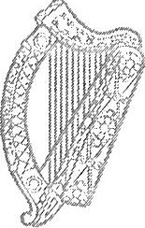
An Roinn Slainte
Departmen t of Health

COVID-19 (Coronavirus)
Advice from the Chief Medical Officer to Parents of School and Pre School Children

2 March 2020 Dear Parents,
You will be aware that following the identification of a confirmed case of Covid-19 in the east of the country, a secondary school will close for 14 days, the duration of the Covid-19 incubation period. Pupils and teachers at that school have been asked to restrict their movements, avoiding crowded settings and any large events, including sporting events, over that time period.

I understand the concern arising from this decision, which was not taken lightly.

The decision to close the school for 14 days is a precautionary one and arises because pupils and teachers may have had direct with the confirmed case.

However, siblings not attending the school concerned, parents and other members of the community are not regarded as contacts and can continue their daily routine as normal.

While there is much to learn about Covid-19, we do know that:

More than 80% of people who have contracted the virus have experienced it in a mild form and generally recover in 2 - 3 weeks, while 20% experience a more severe form of the disease, this tends to be associated with older age (greater than 60 years old and having other health issues, e.g. heart disease).

As with influenza, the people most at risk are the elderly and those with underlying illness

- Covid-19 does not to appear to be as infectious as some other diseases - while a person with measles typically passes the virus on to 14 other people, with Covid-19 that number is estimated between two and three.

- Covid-19 is spread through close contact with an infected person' s body fluids (e.g. droplets from coughing or sneezing), or by touching surfaces that an infected person has coughed or sneezed on.
Bloc 1, Plaza M iseach, 50 • 58 Sraid Bhag6id lochtarach, Baile Atha Cliath 2, D02 XW14
Block 1, Miesian Plaza, 50 • 58 Lower Baggot Str eet, Dublin 2, D02 XW 14 T +3 53 1 635 4000 I info@health.gov.ie
www .health.gov.ie

- Current information suggests the Covid-19 virus may survive a few hours on surfaces and can be killed with simple household disinfectants.

- The most important action we can take to protect ourselves from Covid-19 is regular hand-washing and good cough/sneeze hygiene.

Finally, I want to reassure you that the Health Services prioritise patient confidentiality in all cases. Our priority is to create an environment where people feel safe and protected when coming forward to seek medical help.

To this end we will not reveal patient details other than the gender, general location (east, west, north, south of Ireland) and the source of the infection. We have called, therefore, on the media to respect patient confidentiality.

Attached is a list of Frequently Asked Questions and there is further information available at www.hse. ie.

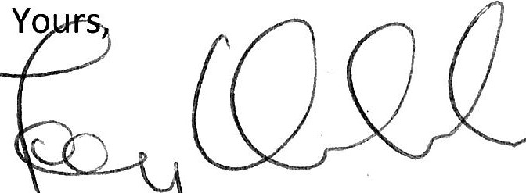
Dr Tony Holohan Chief Medical Officer Department of Health

COVID-19 (Coronavirus)

Covid-19
Covid-19 is a novel (new) virus, not previously seen in humans, identified in Wuhan, China in December 2019. The first cases were identified in people working in a seafood and live animal market in Wuhan. It is thought that humans picked up the virus from animals at the market.
Covid-19 is spread
directly, through contact with an infected person's body fluids (e.g. droplets from coughing or sneezing)
indirectly, through contact with surfaces that an infected person has coughed or sneezed on and which are, therefore, contaminated with the virus.
Current information suggests the virus may survive a few hours. Simple household disinfectants can kill the virus.

Covid-19 - Symptoms
a cough
shortness of breath breathing difficulties fever (high temperature)

Covid-19 - Treatment
While there is no specific treatment for the virus many of the symptoms can be treated.
If you or your child get the viru s, your healthcare professional will advise treatment based on your symptoms.

Close contact
Close contact, as defined by the World Health Organization (WHO), involves either face to face contact or spending more than 15 minutes within 2 metres of an infected person. The risk of transmission th rough casual contact, e.g. passing by on the street or in a shop, is low.

Close contact - advice for parents, siblings, housemates, workmates
People who share living or work space with individuals classified as a close contact of a confirmed case should carry on their daily routines as normal - these individuals have not themselves had close contact with a confirmed case.

Contact Tracing
In the event of a confirmed case, a clinician will speak to the patient to gather details of places they visited and the people they've been in contact with since they became unwell or, in the case of international travellers, since they arrived in Ireland. This will provide a detailed picture of the people we need to contact, such as family members, colleagues or fellow travellers.

This list of people will be contacted with instruction and advice on what to do if they become symptomatic.

If a member of the contact list becomes symptomatic, we isolate and test this individual and provide treatment, if confirmed.

NB: A close contact involves either face to face contact or spending more than 15 minutes within 2 metres of an infected person. We do not contact trace persons that may have passed by on the street or in a shop. The risk of contact in that instance is very low.

Patient confidentiality
The Department of Health recognises and appreciates the public's need and desire for reliable information and is committed to providing clear, accurate and up-to-date information on Covid-19, so that the public can take appropriate personal preventative measures, such as those described on the HSE website.

It is equally important to balance this commitment to clarity and transparency against the obligation to protect individuals from potential stigmatisation and discrimination. This is achieved by respecting individual privacy as far as possible, while ensuring that all necessary information directly relevant to the public good is shared in a timely manner.

It is in the public interest not to disclose personal information which could negatively impact upon a person's willingness to disclose symptoms suggestive of Covid-19.

Restricted Movement
Individuals who have had close contact with a confirmed case of Covid-19 are asked to restrict their movements for 14 days, the incubation period of the virus. These people are deemed to be well, however public health officials will follow up with them on a daily basis, and in the event that they develop symptoms, they will be tested.

Restricted movement means avoiding crowded settings and large gatherings, for example concerts and sporting events.

